Create project like the following figure:

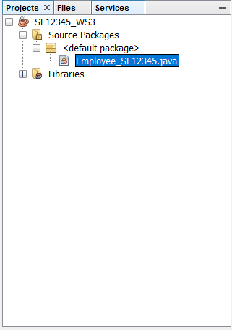

Create file like the following figure:

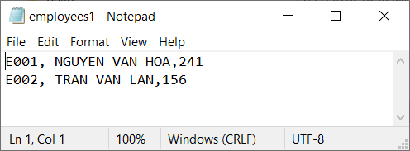

1. Design the GUI like the following figure**(10 marks)**

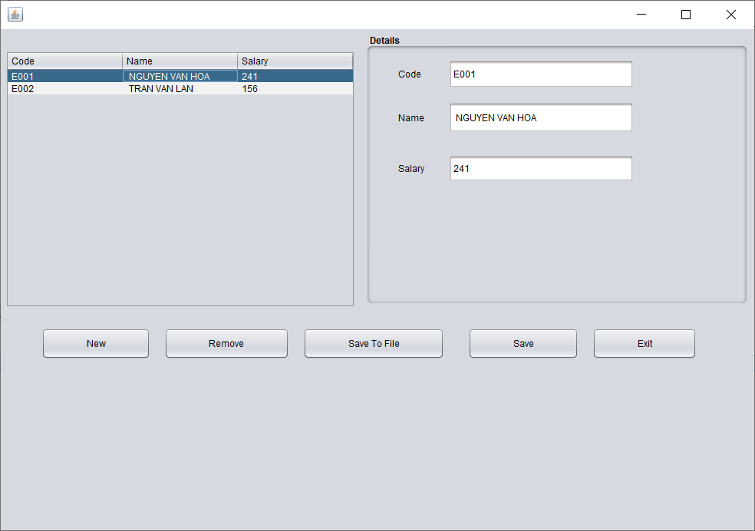

Performance requirements:

* Read data from file to table.
* Button New : Enter a new employee.
* Button Remove : Remove cuurent employee.
* Button Save To File : Write the employee list to File.
* Button Save : Display new employee on the table.
* Button exit : Close program.